Lab 3 Report:

SECTION 1:

1. all new users and groups created in Active Directory

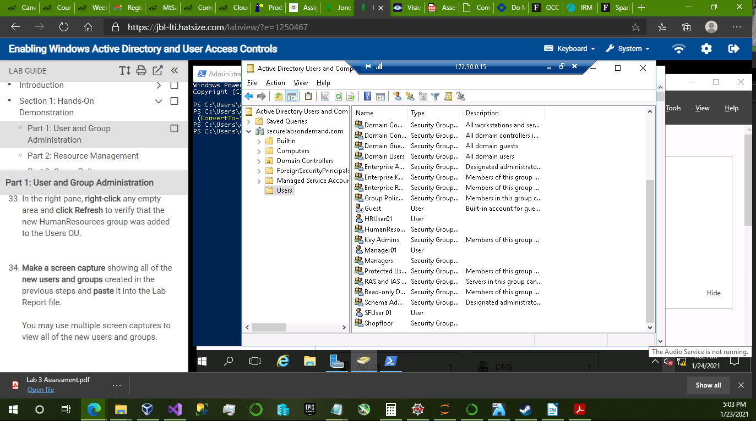

2. unsuccessful access error messages in the LabFiles folder for SFUser01

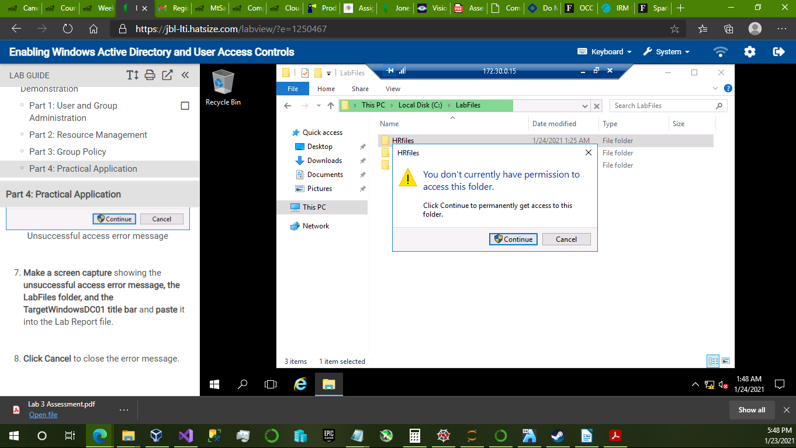

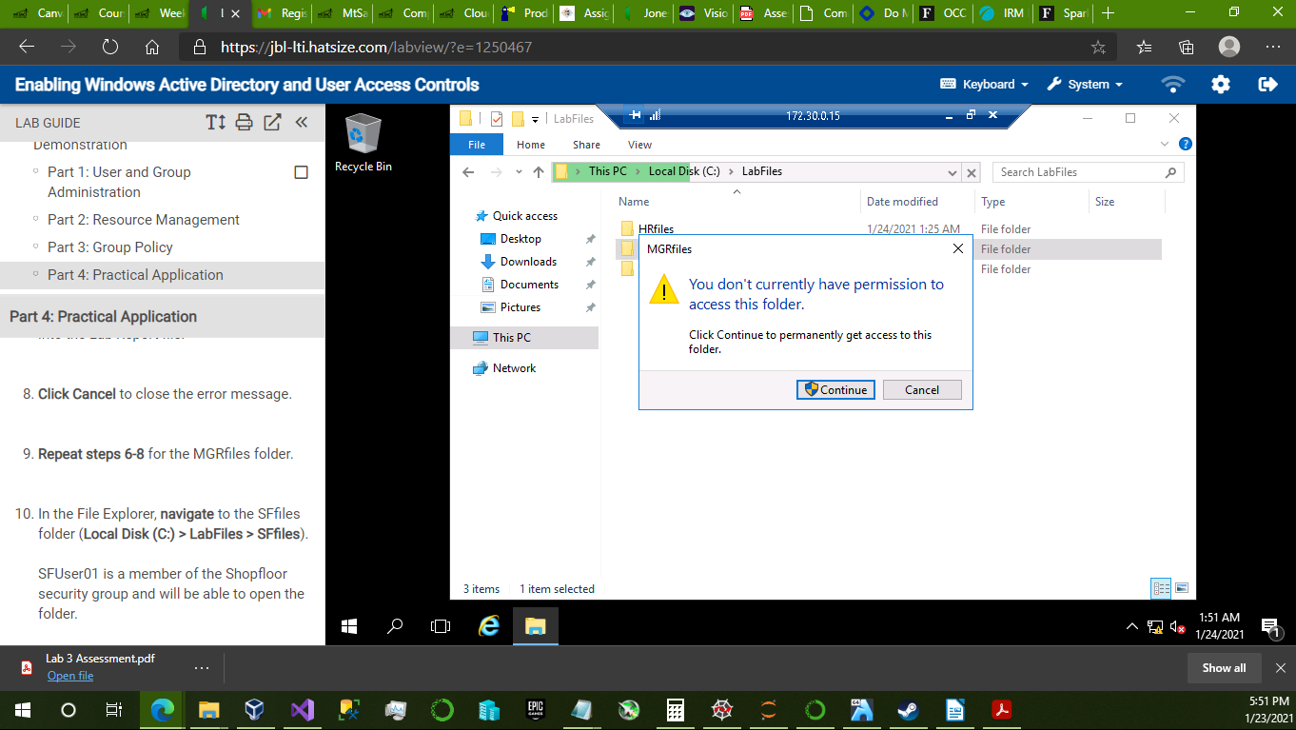

3. a file successfully created in the SFfiles folder for SFUser01

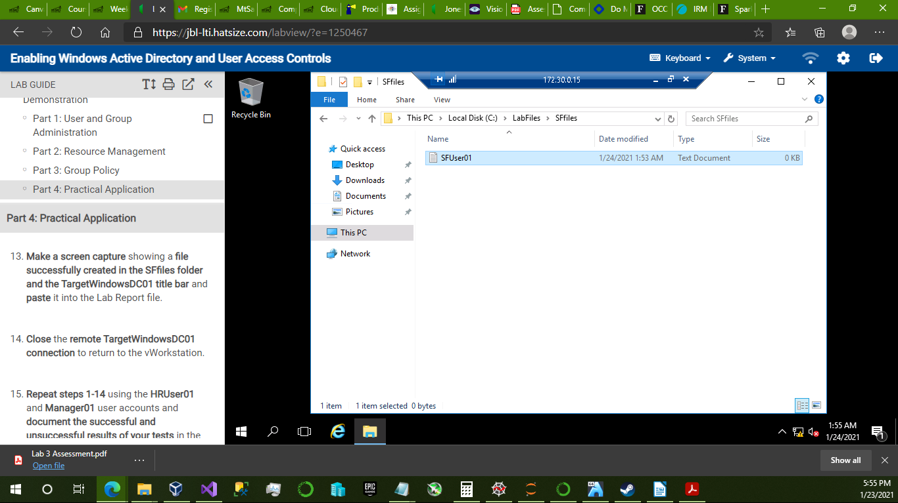

4. successful and unsuccessful results for HRUser01 and Manager01

HRUser01, successful:

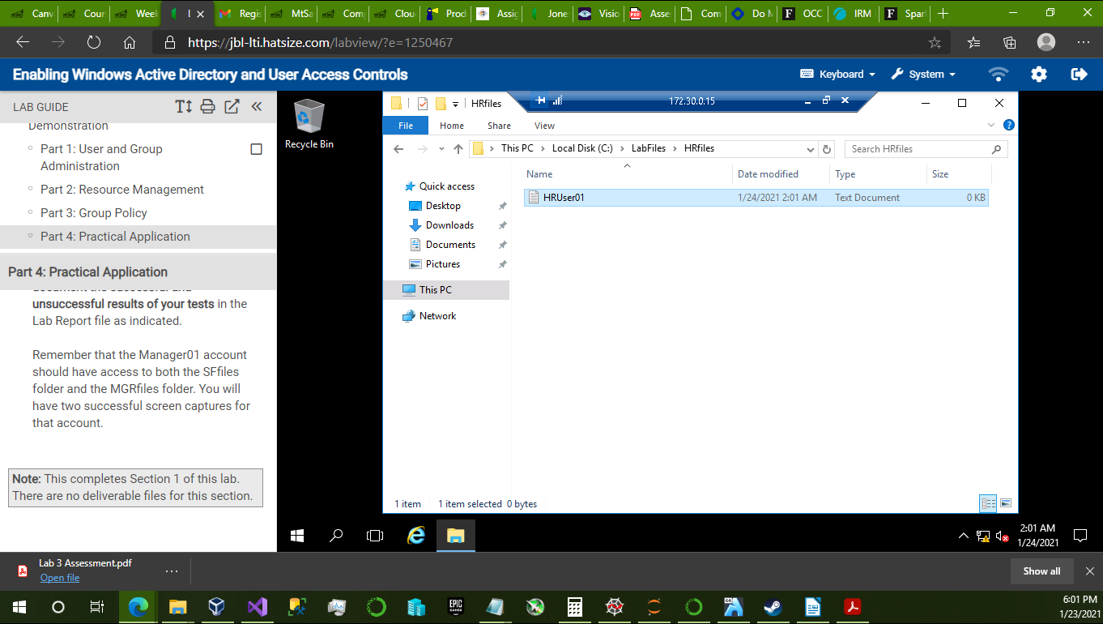

HRUser01 unsuccessful:

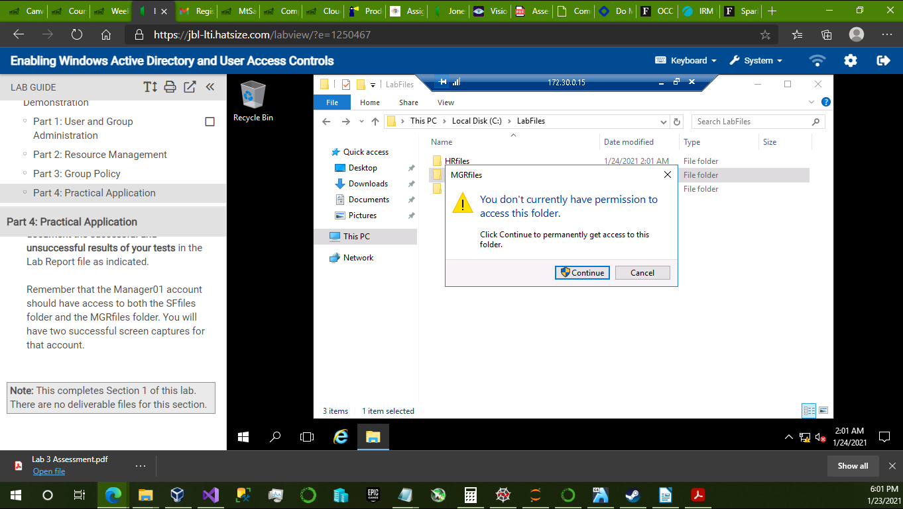

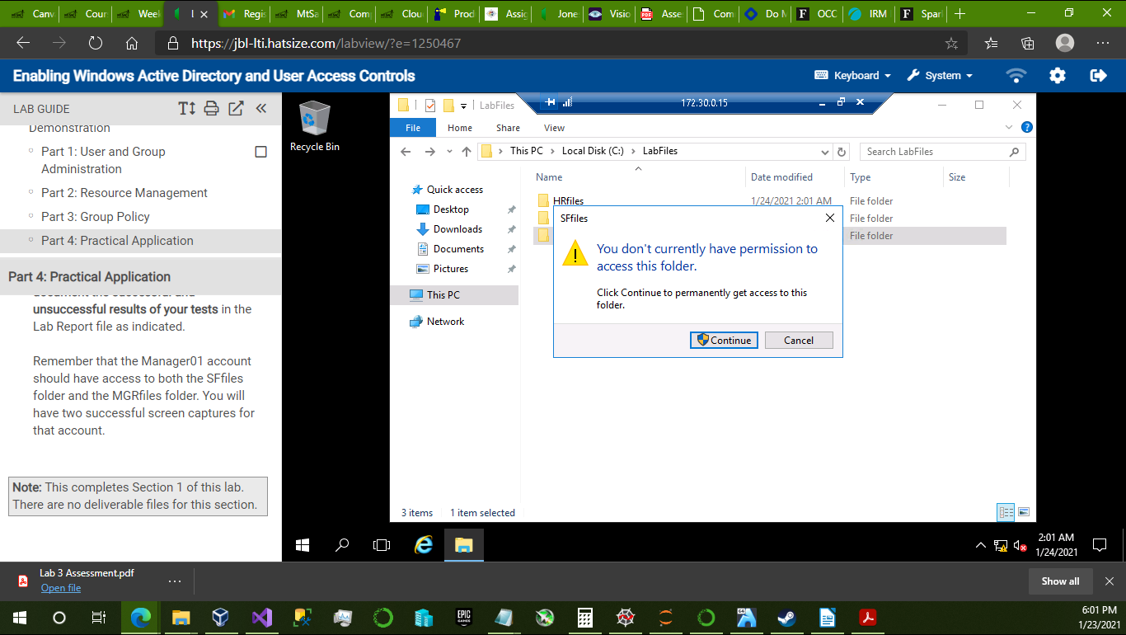

Manager01 successful:

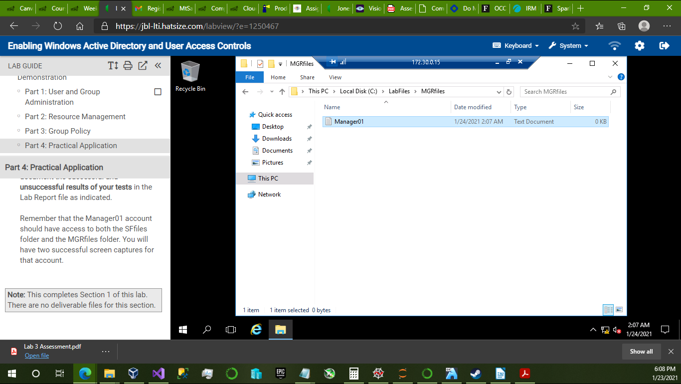

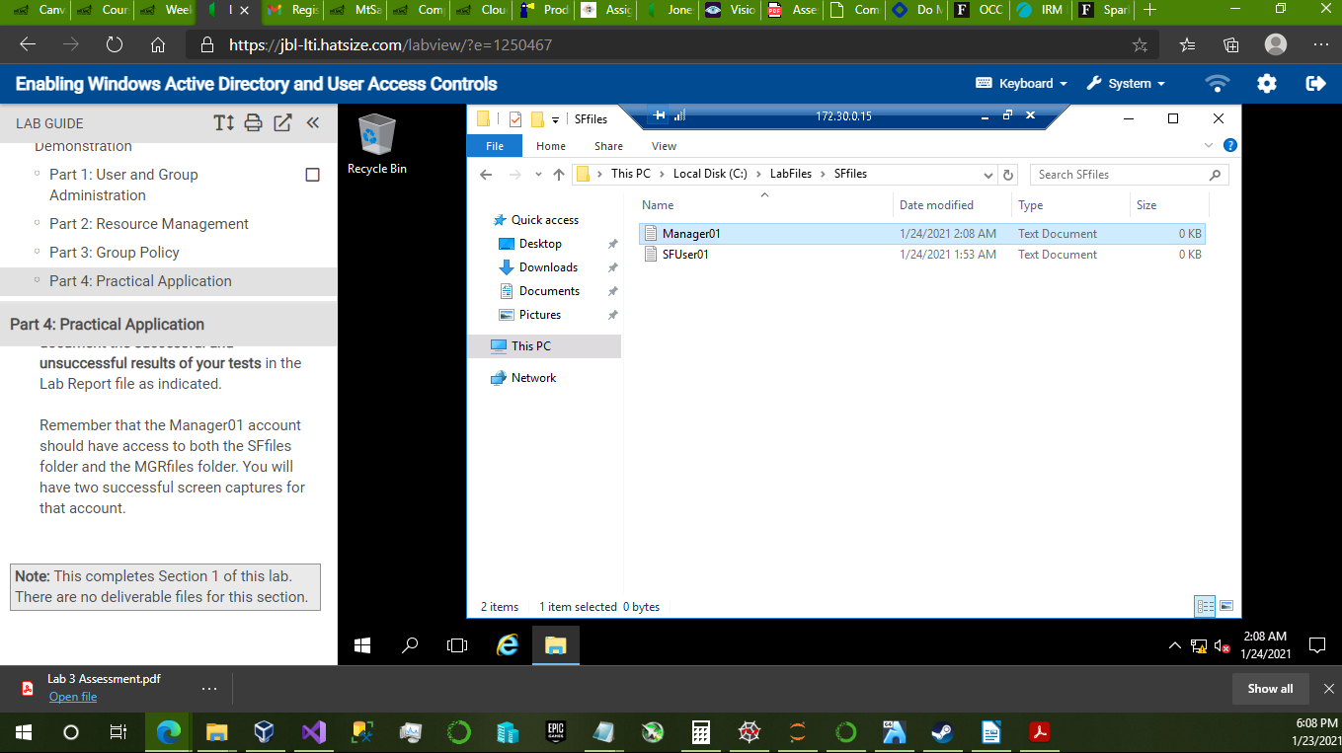

Manager01 unsuccessful:

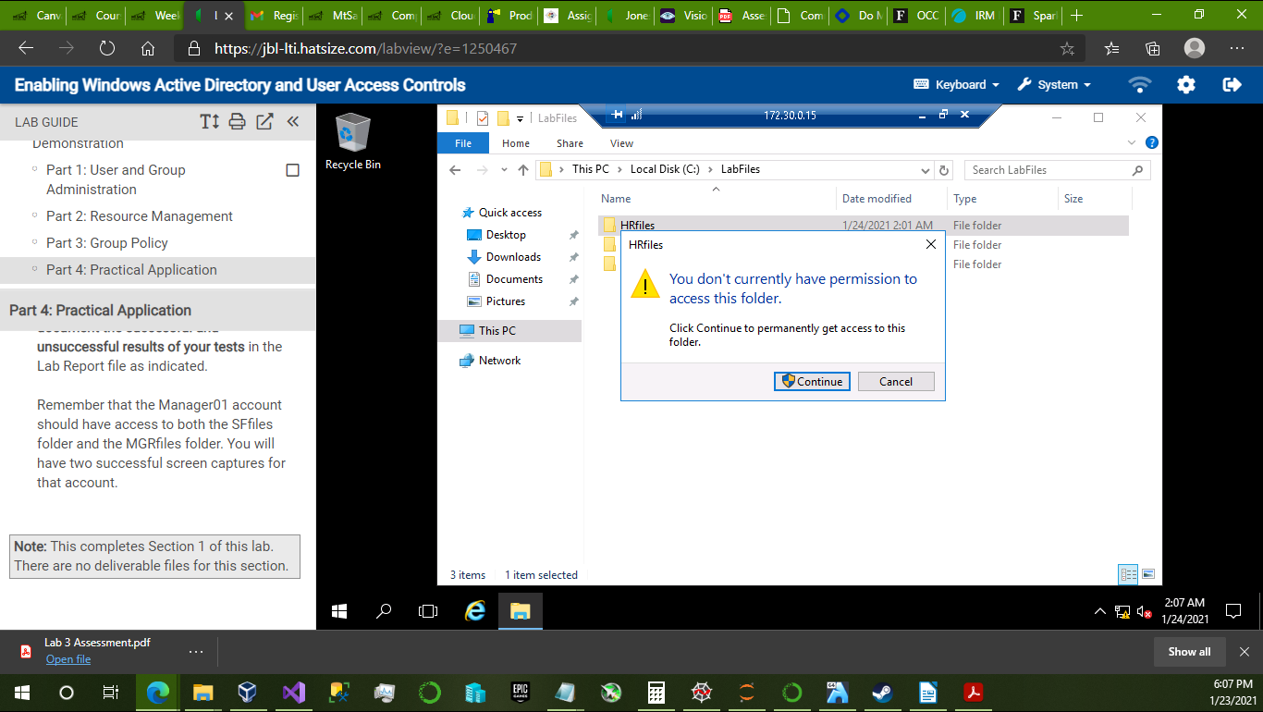

SECTION 2:

1. all new users and groups created in Active Directory

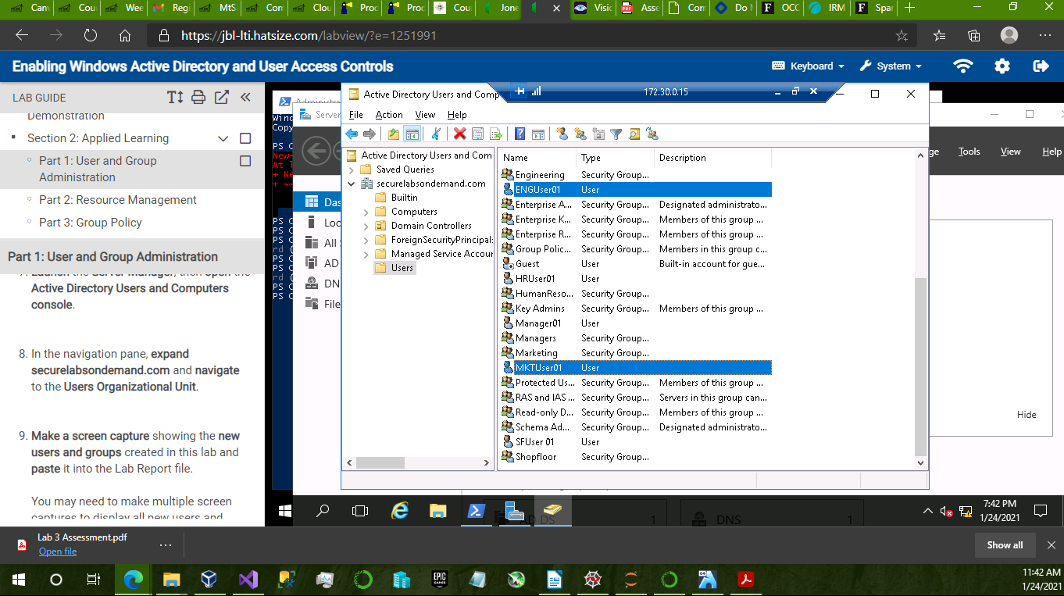

2. Powershell commands used to restrict the ENGfiles and MKTfiles folders

Powershell commands restricting ENGfiles:

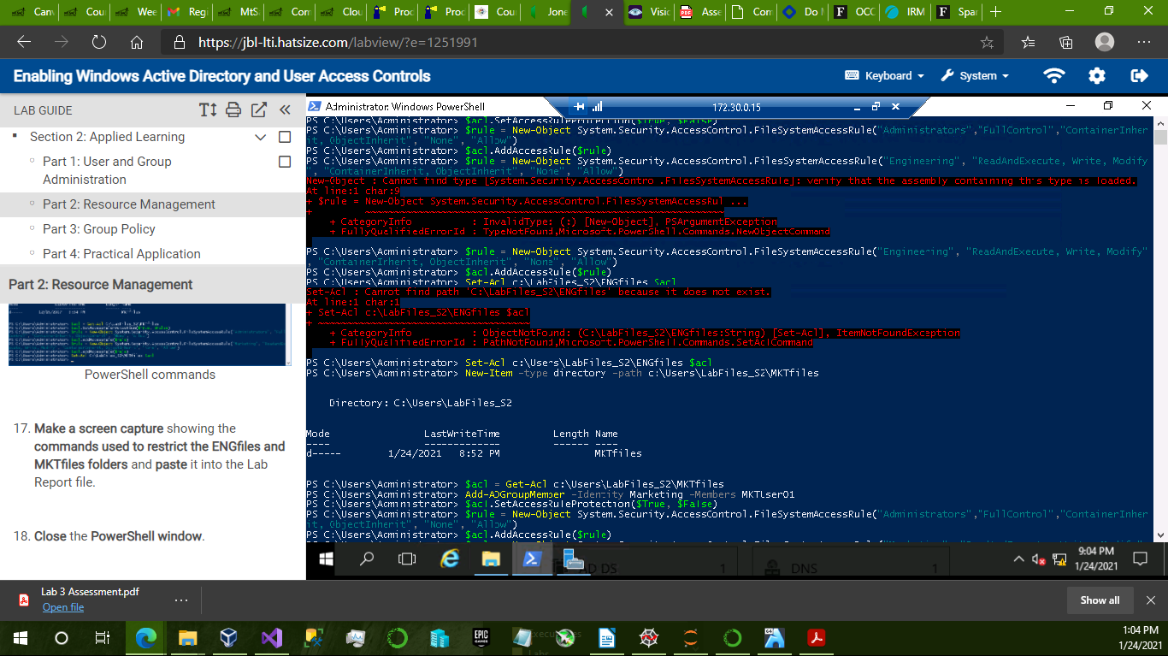

Powershell commands restricting MKTfiles

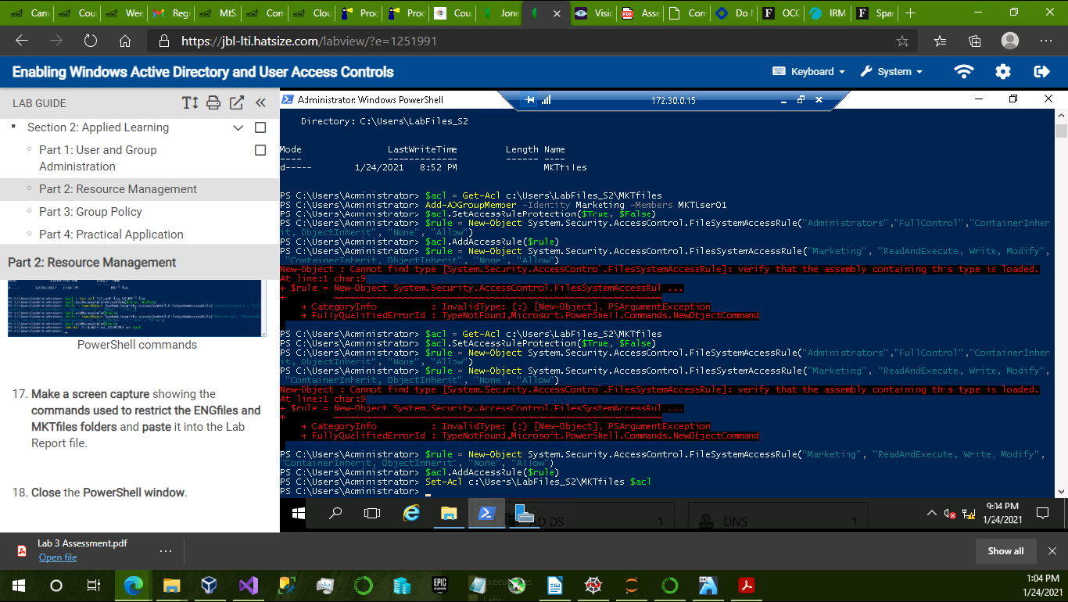

3. unsuccessful access error message in the LabFiles folder for ENGUser01

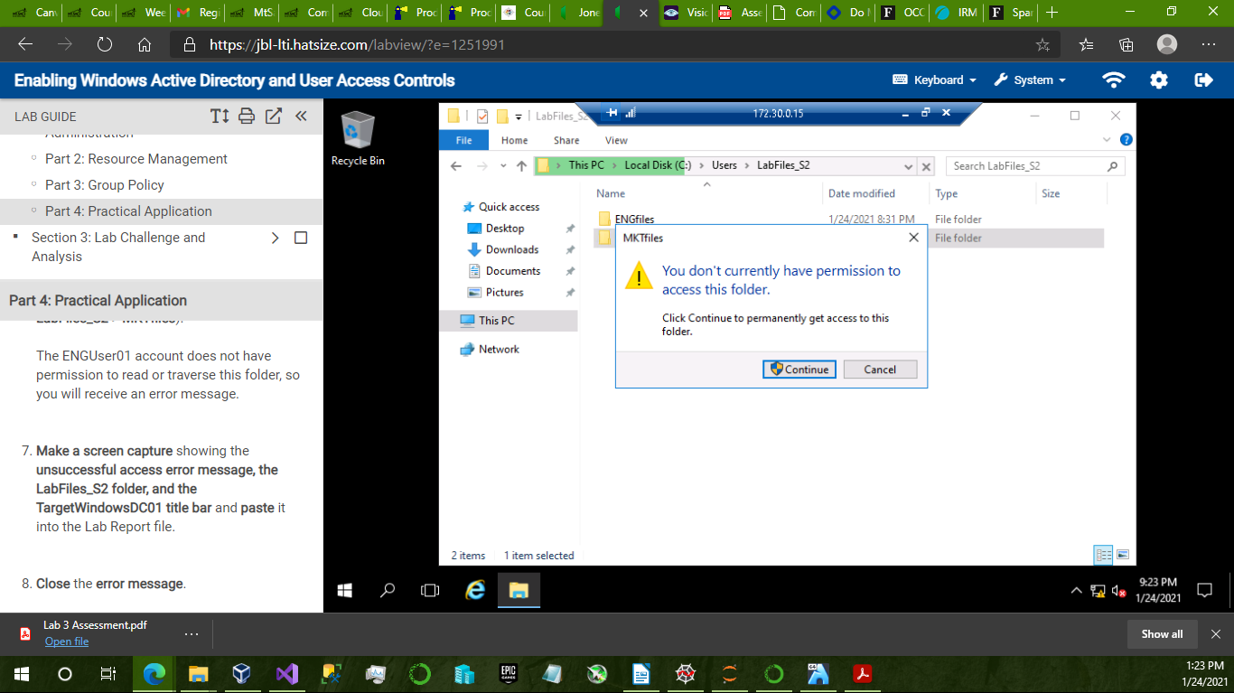

4. successful text file creation in the ENGfiles folder for ENGUser01

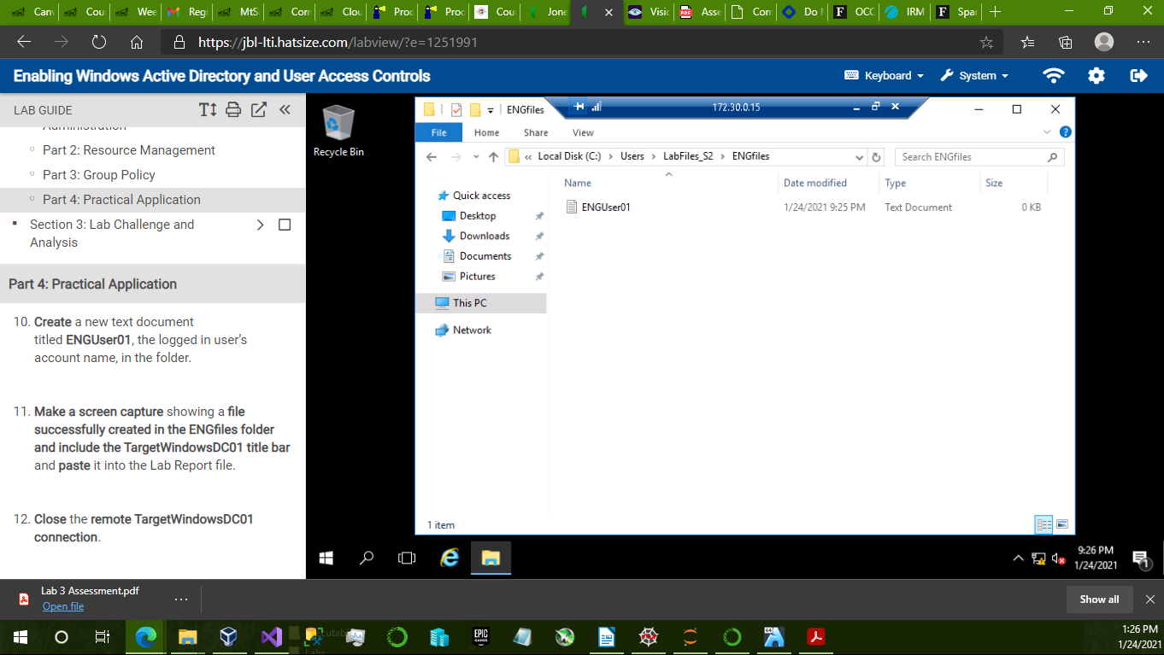

5. successful and unsuccessful results for MKTUser01

